
LA GRANDEE INTERNATIONAL COLLEGE
Simalchaur, Pokhara Nepal
A Mid-Term Report
On
“LevelUp”

Submitted to:
Bachelor of Computer Application (BCA) Program
In partial fulfilment of the requirements for the degree of BCA under
Pokhara University
Submitted by:
Name: | Course | Semester | P.U. Registration Number
Deepak Chhantyal | BCA | 4th | 2021-1-53-0348
Deepak Chhantyal | BCA | 4th | 2021-1-53-0349
Roshan Adhikari | BCA | 4th | 2021-1-53-0363

Date:05/11/2025

TABLE OF CONTENTS
TABLE OF FIGURES iii
1. Introduction 1
2. Problem Statement 2
3. Objectives 3
4. Methodology 4
5. System Design 5
5.1 Data Flow Diagram 5
5.1.1 Level – 0 DFD 5
5.1.2 Level – 1 DFD 6
5.2 Database Design 7
6. Entity Relationship Diagram 8
7. Project Gantt Chart 9
8. Project Development 11
9. Conclusion 13

TABLE OF FIGURES
Figure 4.1. Waterfall Model 4
Figure 5.1.1 Level-0 DFD 5
Figure 5.2.2 Level-1 DFD 6
Figure 5.2. Database Diagram 7
Figure 6.1 ER-Diagram 8
Figure 7.1 Project Gantt Chart 9

Introduction
The LevelUp App is an innovative community-based platform designed to support individuals in developing their skills through collaboration, consistent engagement, and gamified learning experiences. In today’s rapidly evolving digital environment, continuous learning and social interaction play an essential role in personal and professional growth. The LevelUp App addresses this need by providing an interactive space where users can join or create communities focused on shared skills or interests. Within these communities, members participate in a variety of quests and challenges designed to enhance their abilities and encourage regular participation. Through active involvement in these activities, users earn experience points and progress through levels, making the learning journey both structured and rewarding.
Beyond individual progress, the platform places strong emphasis on teamwork and collective development. It introduces clans, which are smaller sub-groups formed within communities to promote collaboration, coordination, and friendly competition among members. This structure not only motivates users to stay active but also fosters meaningful social connections and a sense of belonging. By integrating a system of ranks and achievements, LevelUp transforms the process of skill development into an engaging and socially driven experience.
The app also incorporates a content management system (CMS) that enables community leaders to manage content, organize events, share learning materials, and maintain an active and organized digital space. This feature ensures that communities remain dynamic, goal-oriented, and accessible to both new and existing members. The combination of interactive learning, social engagement, and administrative functionality sets LevelUp apart as a holistic platform that blends education with entertainment.
From a technical perspective, significant progress has been achieved during the mid-term development phase. The user authentication system has been successfully implemented, allowing secure registration, login, and access management. The community creation and management modules are fully functional, enabling users to form and customize communities according to their interests. The clan system has been integrated within communities, supporting intra-community collaboration and competition. On the backend, the database architecture is developed using PostgreSQL in combination with Prisma ORM, ensuring robust, efficient, and scalable data handling. On the frontend, the Next.js framework has been utilized to build a responsive, modular, and user-friendly interface. Core components such as the authentication flow, user dashboard, and community pages are already functional, establishing a strong foundation for future expansion.
The LevelUp App is envisioned not only as a digital platform but also as a growing ecosystem that encourages self-improvement through meaningful participation. It seeks to combine learning, motivation, and social interaction in one unified experience. As this report presents, the development process has been guided by user-centered design principles, iterative testing, and modern web technologies to ensure both usability and performance.
This mid-term report aims to provide a comprehensive overview of the project’s purpose, progress, and future direction. It discusses the conceptual design, development methodology, and major milestones achieved so far, while also reflecting on challenges encountered during implementation. Furthermore, it outlines the next steps planned to refine, expand, and optimize the LevelUp App as it moves toward completion and deployment..

Problem Statement
Lack of engagement in online learning platforms: Many existing learning platforms fail to maintain user interest over time due to monotonous content delivery, lack of interactive features, and absence of gamified elements.
Limited motivation for continuous participation: Users often struggle to stay consistent in skill development because current systems do not provide rewards, recognition, or measurable milestones to encourage regular involvement.
Minimal practical application of skills: Most educational and community platforms focus on passive learning or discussion without providing structured opportunities for users to complete challenges, tasks, or projects that enhance practical skills.
Insufficient collaboration and peer interaction: Current systems often lack mechanisms for meaningful collaboration among users, resulting in limited peer-to-peer learning and community engagement.
Fragmented approach to community and group activities: Many social or learning platforms either focus solely on individual progress or on social interaction, but do not combine both effectively, leaving a gap in coordinated group learning or competitive engagement.
Challenges in community management: Existing community-based platforms offer limited tools for content management, event organization, and member administration, making it difficult for leaders to maintain active and organized communities.

Objectives
The main objective of this project is to have easier for the users. The objectives are :-
1. To create an engaging, community-driven platform for skill development.
2. To encourage collaborative learning and healthy competition.

Methodology
We are using “The Waterfall model” to develop this project. The waterfall methodology is a sequential development process that flows like a waterfall through all phases of a project (analysis, design, development, and testing). After the completion of a step, then only we can proceed towards the next step.
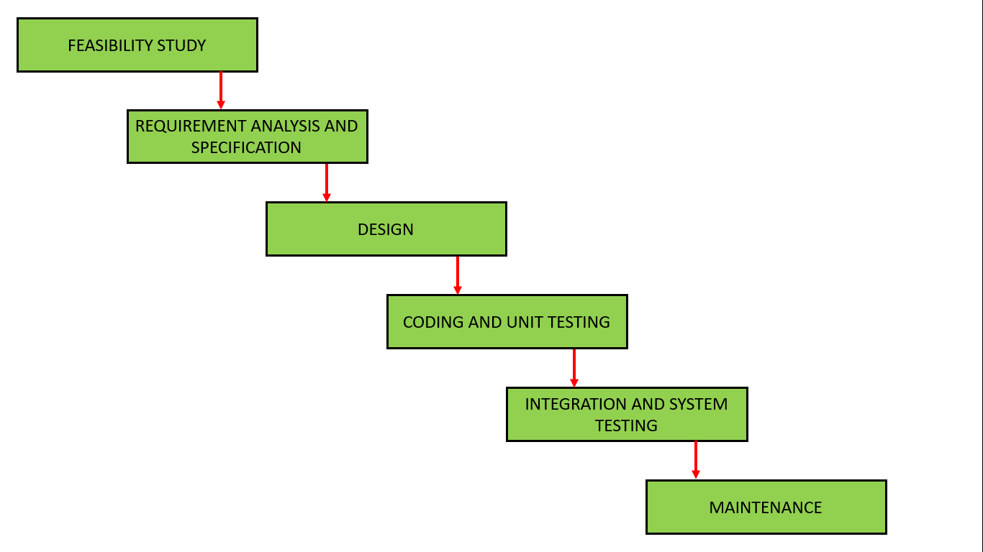
Figure 4.1. Waterfall Model

System Design

Data Flow Diagram

5.1.1 Level – 0 DFD
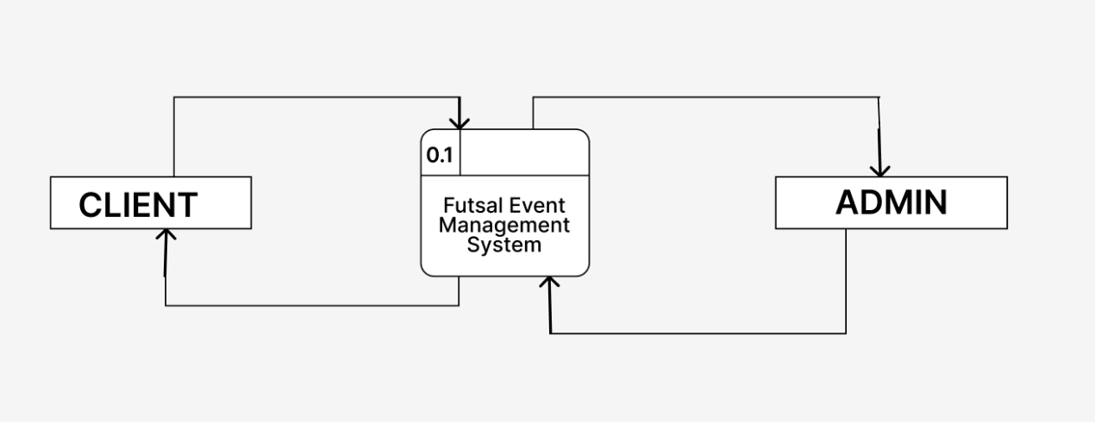
Figure 5.1.1 Level-0 DFD

5.1.2 Level – 1 DFD
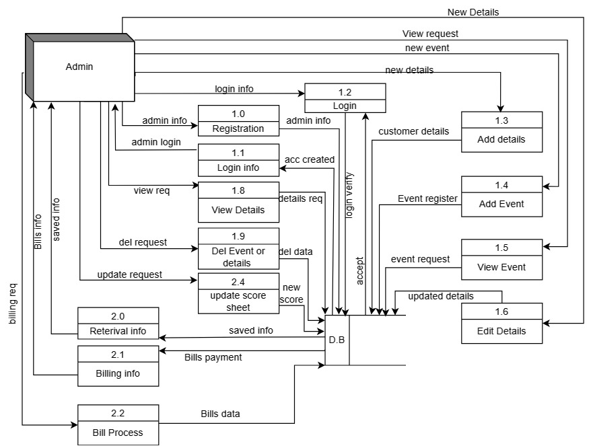
Figure 5.2.2 Level-1 DFD

5.2 Database Design
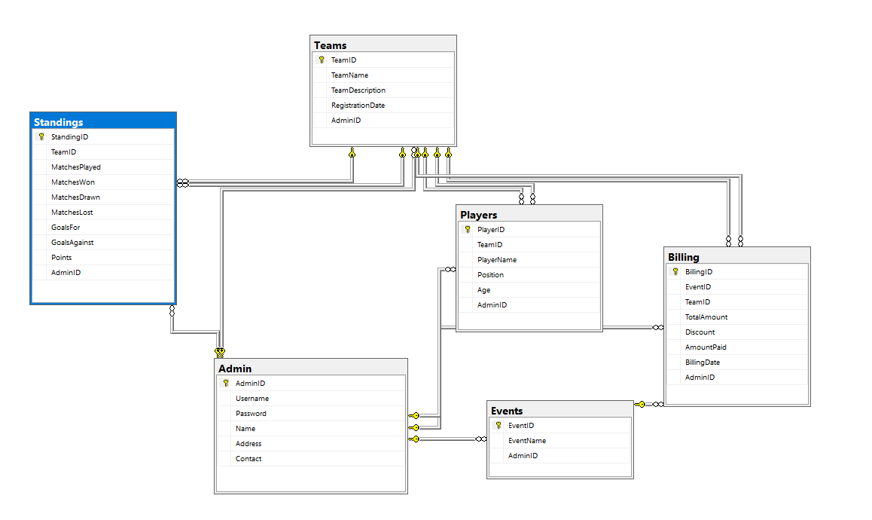
Figure 5.2. Database Diagram

Entity Relationship Diagram
For Designing, we use Er-Diagram
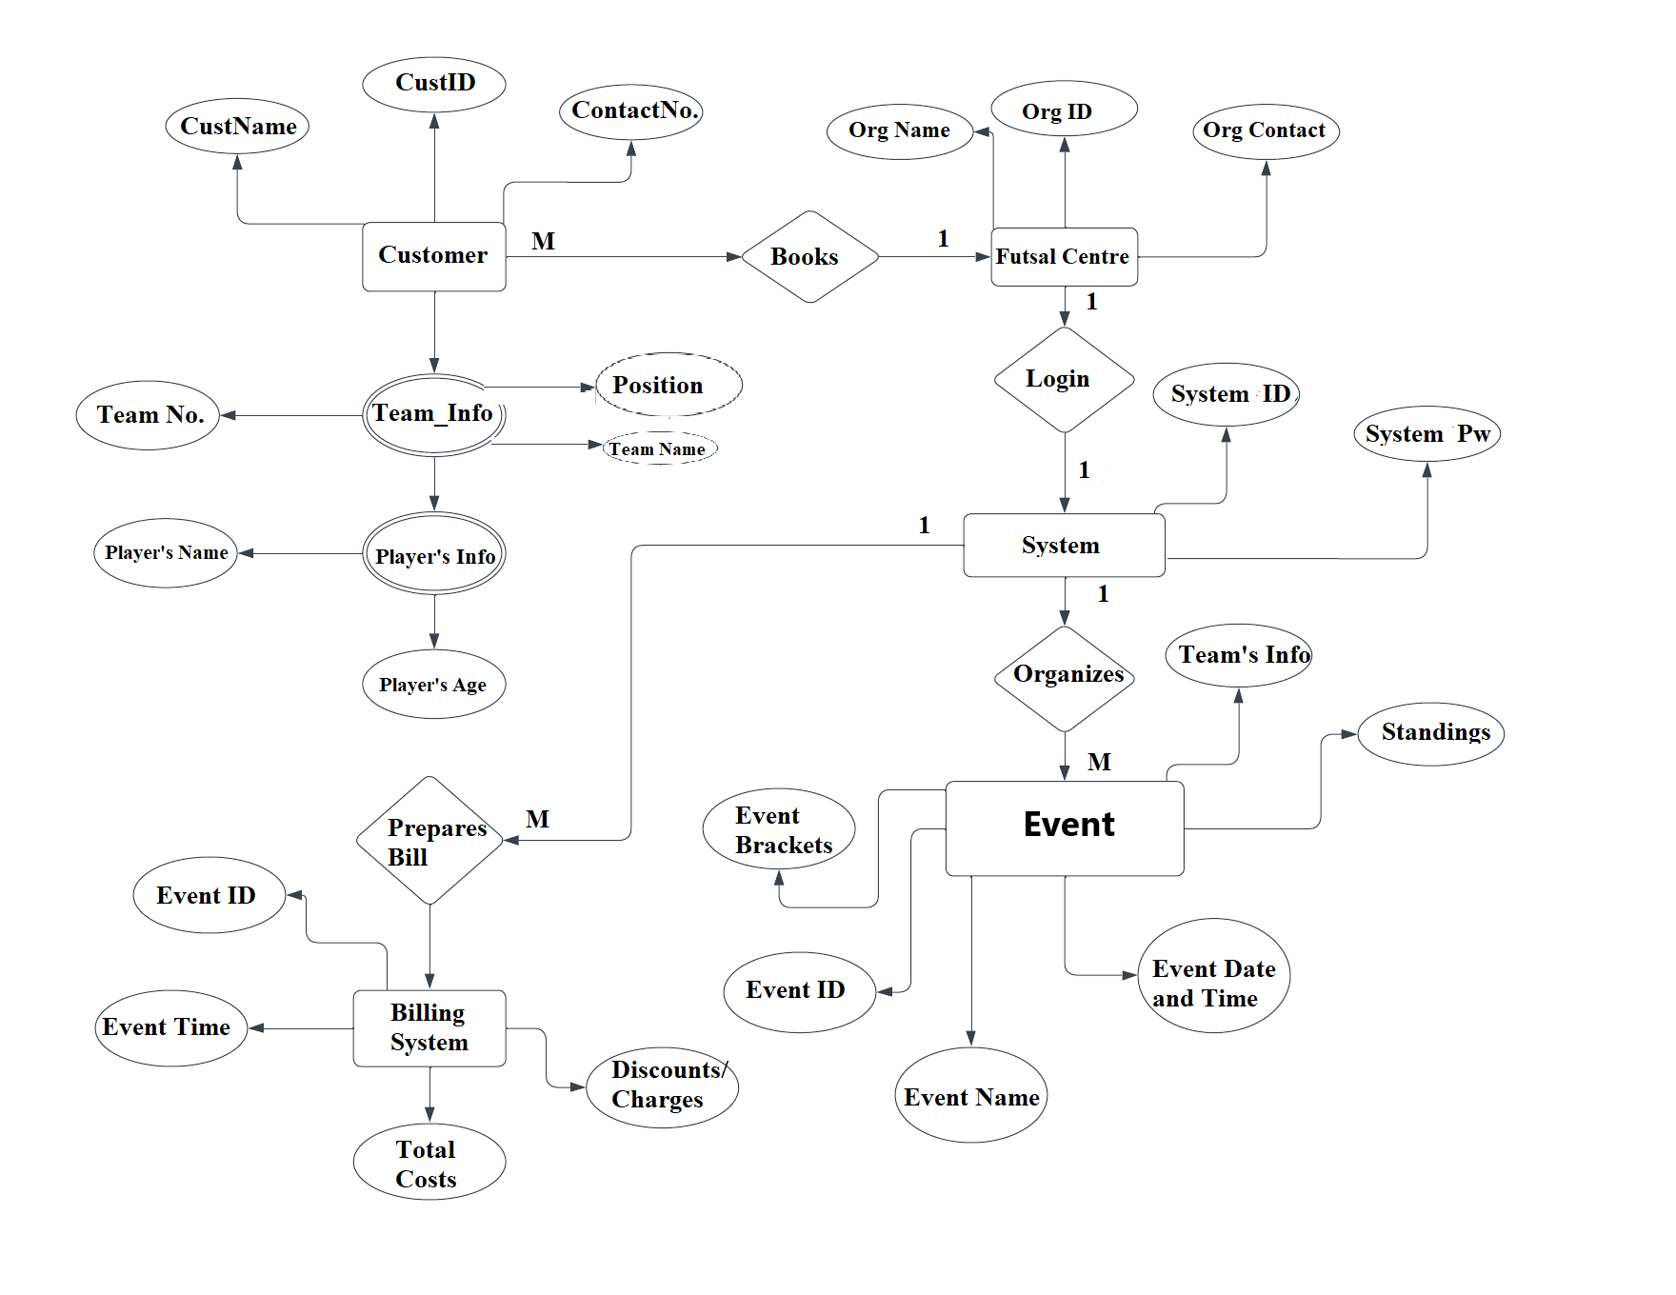
Figure 6.1 ER-Diagram

Project Gantt Chart
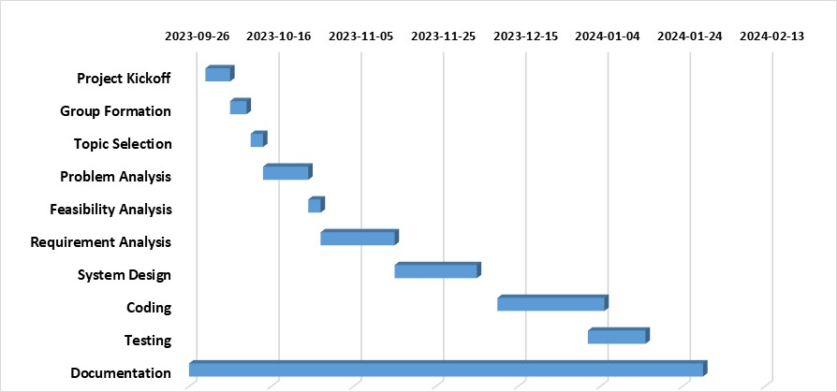

Figure 7.1 Project Gantt Chart

Project Development
The development of the Futsal Event Management System (FEMS) has been progressing steadily, with significant achievements in various aspects of the project. This report provides a comprehensive overview of the work completed so far, including the Data Flow Diagram (DFD), Entity-Relationship (ER) Diagram, Database Diagram, Requirement Analysis, and the implementation of login and registration functionalities.
1. Data Flow Diagram (DFD) , the DFD serves as a visual representation of the system's data flow and processes. We successfully created a detailed DFD, identifying key processes, data stores, and data flows within the FEMS. This diagram has been crucial in understanding the system's overall architecture and has guided subsequent development phases.
2. Entity-Relationship (ER) Diagram, the ER Diagram outlines the relationships between entities in the database schema. We have meticulously designed the ER Diagram, capturing essential entities such as Teams, Players, Standings, Events, Admins, and Billing. Relationships and attributes have been clearly defined, providing a solid foundation for the database structure.
3. Database Diagram Building upon the ER Diagram, the Database Diagram illustrates the tables, relationships, and constraints within the FEMS database. Each table, including Admin, Teams, Players, Standings, Events, and Billing, has been carefully crafted to ensure efficient data storage and retrieval.
4. Coding Progress The coding phase has seen substantial progress, with a strong emphasis on clean, modular, and secure code practices. The backend logic for user authentication, registration, and session management has been implemented. The frontend components for the login and registration forms have been integrated, providing a seamless user experience.
Challenges and Mitigations Throughout the development process, some challenges were encountered, including database connectivity issues and ensuring data integrity. These challenges were addressed by refining the database schema, optimizing queries, and conducting rigorous testing. Next Steps Looking ahead, the development team is focused on implementing additional features such as team creation, event management, and billing functionalities. System testing and validation will be intensified to ensure a robust and error-free application.

Conclusion
The Futsal Event Management System development has made substantial progress, meeting key milestones in design, database implementation, and functional features. The successful completion of login and registration functionalities marks a crucial step toward delivering a comprehensive and user-friendly solution. The project remains on track, with a clear roadmap for future development, testing, and deployment. This progress report highlights the dedication of the development team, effective collaboration with stakeholders, and the systematic approach to achieving project goals. The FEMS is poised to become a valuable tool for managing futsal events efficiently and enhancing the overall user experience.

